Landscaping - Fairway Mowing 2.0
Verification Test Cases
Produced by Nate Wagstaff, 03/12/2026 08:45:07 PM UTC

Table of Contents

No table of contents entries found.

LFWM2-VERTC-940 | Mower to not stop for grass trimmings
Objective:
- When a mower mows very thick or long grass, the mowed grass clippings can be thrown where the LiDAR can "see" the grass clippings. The mower must not stop for grass clippings

Scope:
- Subsystem test (VAI)

Assumptions:
- A fairway is available to mow that has long grass
- The fairway has been mapped and has a plan in Mobius
- The fairway is free from all obstacles that may stop the mower
- The group of thrown grass clippings needs to be larger than 6 inches across and 1 foot long

Verification Method
Steps
Action | Expected Results | Notes
Manually move the mower to the fairway with long grass, assign the mower to yourself in Mobius, and load a plan for the fairway | When the mower is moved to the fairway, assigned to you, and a plan loaded, the mower will be ready for the test to start
Start the mower on the fairway with long grass using the loaded plan | While the mower is mowing long grass, grass clippings will be thrown in front of the mower
Allow the mower to complete the plan on the fairway | The mower shall not stop at any time due to grass clippings getting thrown in front of the mower
Upstream Relationships:
LFWM2-SYSRQ-292 Mower to not stop for grass trimmings
LFWM2-VERTC-942 | Screen Data is not lost when phone is locked and unlocked after five minutes
Objective:
- <Clearly describe what the test aims to verify or validate.>

Scope:
- <Specify the boundaries of the test (e.g., subsystem, complete system).>

Assumptions:
- User is logged into MOBIUS Mobile Application
- User has opened to the error report screen
- User has entered data into the Title and Description fields
- User has locked the phone
- At Least Five minutes have passed
- JWT Token has not expired

Verification Method
Steps
Action | Expected Results | Notes
Log into Mobius mobile application | User is logged into Mobius mobile application
Navigate to the error report screen and type "Test" in the Title and Description fields | Data will be entered
Lock phone | Phone locks
Wait more than 5 minutes
Unlock phone | Mobius mobile application will open directly to the error report page and User will see "Test" in both Title and Description fields
Upstream Relationships:
LFWM2-SubSys_Rqmt-41 Retain User Authentication on Mobile Application Disconnect
LFWM2-VERTC-943 | Verify SMU requires WAT on the required frequency
Objective:
- The SMU requires WAT before automated operation can begin on a predefined frequency

Given an SMU in specification and the SMU is powered on
When the timeframe between the last execution of the WAT expires
Then the SMU will send an alert to require a new execution of the WAT before autonomous running can continue

Scope:
- <Specify the boundaries of the test (e.g., subsystem, complete system).>

Assumptions:
- <Note any assumptions made prior to testing.>

Verification Method
Steps
Action | Expected Results | Notes
After executing a Walk Around Test user waits 24 hours and attempts to operate the mower autonomously | User will be required and informed by an alert to perform a Walk Around Test before the SMU will allow autonomous running
Upstream Relationships:
LFWM2-SubSys_Rqmt-20 WAT Required Frequency
LFWM2-VERTC-944 | SMU Kill Ignition on Breached Hazard Zone
Objective:
- (TBD)

Scope:
- (TBD)

Assumptions:
- The mower is in autonomous mode
- There are no errors/e-stops preventing the mower from operating autonomously
- There is an object taller than 8 inches and wider than 3 inches that is movable by a tester

Verification Method
Steps
Action | Expected Results | Notes
Take note of where you plan on moving the mower to. Use the measuring tape to mark out 1.2 and 1.0 meters away from the center point of where the mower will be | There will be a marked point 1.2 and 1.0 meters away from the center point of the mower's location during testing
Move the mower inside the previously created drivable area, free of any obstacles prior to testing  Once the mower is inside the drivable area, set the mower to Autonomous mode and perform a local confirmation to clear any estops | The mower shall be in autonomous mode and clear of any estops
While the mower is in autonomous mode, move the object to 1.2 meters away from the front of the mower | The SMU shall not kill the ignition
While the mower is in autonomous mode, move the object to 1.0 meters away from the front of the mower | When the object breaches the hazard zone (1.1 meters) the SMU shall kill the ignition of the mower, shutting down the engine.
Perform steps 3 and 4 for each side of the mower (front, left side, right side, back) | The SMU shall kill the ignition when the 1.1 meter hazard zone is breached from all sides of the mower
Upstream Relationships:
LFWM2-VERTC-945 | WAT Contiguous Validation
Objective:
- We want to prevent completion of non-neighboring zones during the walk-around test to minimize the number of false-positives. By having the operator walk through zones contiguously, they will be able to confirm if a zone was wrongfully marked as complete.

Scope:
- TBD

Assumptions:
- A mower with LiDAR installed
- A mower with an SMU installed
- A map with a drivable area published to a server
- An open space to complete the test in

Verification Method
Steps
Action | Expected Results | Notes
Upstream Relationships:
LFWM2-SubSys_Rqmt-21 WAT Contiguous Validation
LFWM2-VERTC-946 | Verify SMU Reports WAT Status to VCU
Objective:
- Verify that when a operator causes a change in status on the walk-around test, the SMU will respond by reporting the new status to the VCU

Scope:
- (TBD)

Assumptions:
- Latest “testable” version of SMU software is loaded.
- SMU is installed in the VAK with correct wiring and power connections.
- SIL/HIL test environments are available and configured.

Verification Method
Steps
Action | Expected Results | Notes
Start the SIL HIL or Physical Mower | The SMU will report that the WAT is required to the VCU
Begin performing the WAT or simulate performing the WAT | The SMU will report that the WAT is active to the VCU
Fail the WAT or simulate failing the WAT | The SMU will report that the WAT is unsuccessful to the VCU
Perform the WAT again this time passing the WAT | The SMU will report that the WAT was successful to the VCU
Upstream Relationships:
LFWM2-SubSys_Rqmt-19 SMU Reports WAT Status
LFWM2-VERTC-947 | VAI Initializing Estop
Objective:
- The VAI needs to fully initialize before the mower can expect it to be capable of processing data. Providing an E-Stop to the FORT is our standardized way of performing these initializations.

Scope:
- TBD

Assumptions:
- A mower with LiDAR installed
- A mower with an SMU installed
- A map with a drivable area published to a server
- An open space to complete the test in

Verification Method
Steps
Action | Expected Results | Notes
Upstream Relationships:
LFWM2-SubSys_Rqmt-39 VAI Initialization E-Stop
LFWM2-VERTC-948 | Filter Grass Clippings from ODOA
Objective:
- ASI would like to verify the VAI is filtering LiDAR data rather than another subsystem so that ASI can verify there is enough processing power to filter raw LiDAR data

Scope:
- Subsystem test (VAI)

Assumptions:
- Mower to not stop for grass trimmings - Test Cases - Jama Software this test needs to be completed prior to this test

Verification Method
Steps
Action | Expected Results | Notes
Where the mower has already mowed a fairway with long grass, log in to the Azure server the mower is currently pointed to, log in to Helm, and create a dataset with blackbox selected from the tags | A dataset with blackbox data will be created and saved to the Azure server
When the server has saved the dataset, move the dataset onto your own computer | The dataset shall be saved to your computer
When the dataset has been saved to your computer, load the dataset into the LiDAR viewing program | While viewing the LiDAR points, each LiDAR point shall have a per-point classification created by the VAI
Upstream Relationships:
LFWM2-SubSys_Rqmt-34 Filter Grass Clippings from ODOA
LFWM2-VERTC-949 | No Safety Impact from Ignoring Grass Clippings
Objective:
- ASI would like to ensure the VAI shall stop the autonomous mower when the mower encounters obstacles in instances of grass clippings getting thrown in front of the mower

Scope:
- Subsystem (VAI)

Assumptions:
- The tester has placed an obstacle on a fairway with long grass
- The obstacle is in an area that will enter the hazard zone as the mower navigates its plan
- The tester moves the autonomous mower to an area where the mower can start a plan autonomously

Verification Method
Steps
Action | Expected Results | Notes
The tester shall start the autonomous mower along its path on a fairway with long grass and an obstacle | The mower shall start along its given plan on the selected fairway for testing
While the mower is mowing the fairway with long grass, grass clippings will be thrown in front of the mower | The VAI will filter out the grass clippings and shall not stop
While the mower navigates its path, it encounters the placed obstacle | When the autonomous mower encounters the placed obstacle the mower shall sound an audible alarm and come to a stop
Upstream Relationships:
LFWM2-VERTC-950 | Offline Planner Short Segment User Warning
Objective:
- <Clearly describe what the test aims to verify or validate.>

Scope:
- <Specify the boundaries of the test (e.g., subsystem, complete system).>

Assumptions:
- <Note any assumptions made prior to testing.>

Verification Method
Steps
Action | Expected Results | Notes
Load a map that includes a fairway shape with sharp angles (not a circle) | A map will be loaded with a fairway
Navigate to the Offline Planner section of Mobius, select a fairway, and start creating a plan for that fairway | A fairway will be selected and the tester will be in the process of creating a plan
While creating a plan, adjust the angle of the path segments in the Swath Generation tab until you, the tester, are left with a path segment equal to, or shorter than, 121.26 inches. This can be verified using the measuring tool | A short path segment will be created, but not connected to a boundary lap
Click on the Next button to navigate to the Connect Swaths step | Mobius will highlight the short path segment in dark yellow/orange. A message will be displayed to the user under the Error panel stating Plan contains short engaged segments that cannot be executed reliably and may require manual intervention | 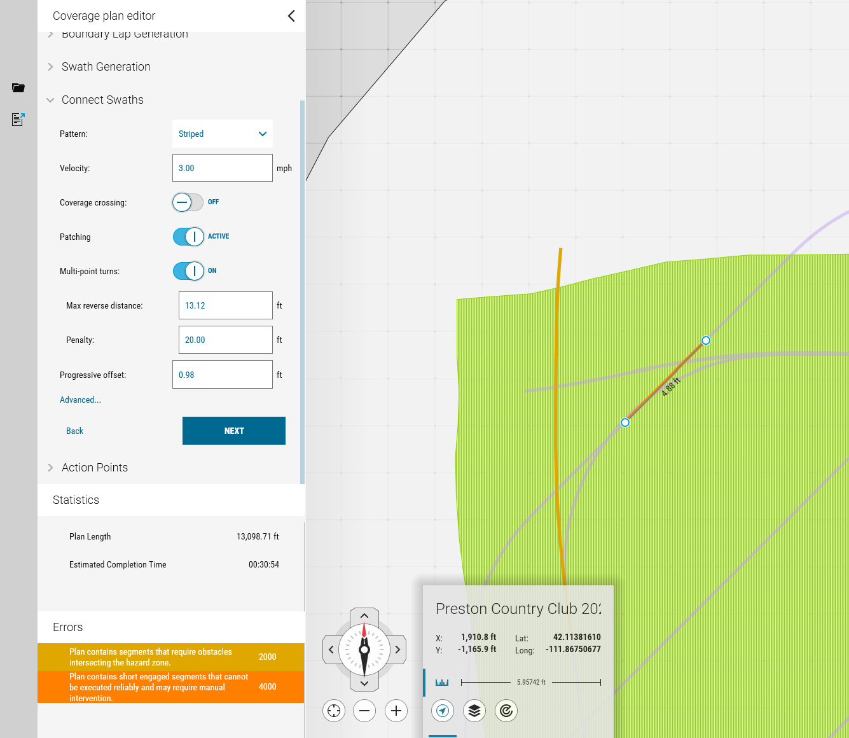
Upstream Relationships:
LFWM2-VERTC-951 | User can add action points to lift and lower reels
Objective:
- A user can add action points with up/down actions along a Path Builder path

Scope:
- <Specify the boundaries of the test (e.g., subsystem, complete system).>

Assumptions:
- <Note any assumptions made prior to testing.>

Verification Method
Steps
Action | Expected Results | Notes
Open Mobius desktop client, connect to a Mobius server, ensure a map is loaded along with a path builder path. | Mobius will be running, a map will be available to a user, and a path will be visible and present.
Navigate to the settings tab, then Global Telemetry, and search for items titled Deck | The tester will be in the Global Telemetry tab and will ensure all telemetry items associated with the word Deck are checked
Navigate to the Path Builder section of Mobius.Select the path builder path that should already be on the map. If there is no path previously created, create a path that is at least 20 ft long | The tester will have the path selected and is now able to create action points along the path
Click along the path beyond the starting point of the path to create an action point. | An action point will be created
Change the action point type from default Velocity Change to Concurrent | The action point will now be a concurrent type action point
Click on the dropdown arrow next to the action point title, click on Select Action, and set the action to Payload Service (1.165.1)/SbrMower CMD: Deck Dn Dist. Leave the distance set to 0.0000 ft | An action point will be created to lower the reels of the mower when the mower passes over the action point
Click along the path beyond the starting down command action point to create another action point. | A second action point will be created past the first action point
Click along the path beyond the starting point of the path to create an action point. | The action point will now be a concurrent type action point
Click on the dropdown arrow next to the action point title, click on Select Action, and set the action to Payload Service (1.165.1)/SbrMower CMD: Deck Up Dist. Leave the distance set to 0.0000 ft | An action point will be created to lift the reels of the mower when the mower passes over the action point
Upstream Relationships:
LFWM2-VERTC-952 | When user creates an Event Report all data points will be selected by Default
Objective:
- Event Report screen will have all available data points defaulted to selected

Scope:
- <Specify the boundaries of the test (e.g., subsystem, complete system).>

Assumptions:
- <Note any assumptions made prior to testing.>

Verification Method
Steps
Action | Expected Results | Notes
User opens the hamburger menu on the mobile app and navigates to the Event Report screen and scrolls down | There should be a checkmark to indicate that each data point is selected
User selects advanced to show all data points | All data points will have a checkmark
Upstream Relationships:
LFWM2-SYSRQ-294 Error Report Data Collection Defaults
LFWM2-VERTC-953 | Event Report default log time is set to 10 minutes
Objective:
- The default timeframe for an Event Report on the mobile app should be set to 10 minutes

Scope:
- <Specify the boundaries of the test (e.g., subsystem, complete system).>

Assumptions:
- <Note any assumptions made prior to testing.>

Verification Method
Steps
Action | Expected Results | Notes
User opens the hamburger menu and selects the Event Report screen | The timeframe starts 10 minutes before the user opened the Event Report screen, this can be seen in the From portion of the time selection. The To will be set to the current time.
Upstream Relationships:
LFWM2-VERTC-954 | Event Report requires the user to select a mower
Objective:
- When a Event Report is created fresh there will be no mower selected
- When a Event Report is created from a notification the mower that was associated with the notification will be preselected
- User cannot submit the Event Report until they have selected a mower

Scope:
- <Specify the boundaries of the test (e.g., subsystem, complete system).>

Assumptions:
- <Note any assumptions made prior to testing.>

Verification Method
Steps
Action | Expected Results | Notes
Open the Hamburger Menu and select the Event Reports screen | In the Vehicles section all mowers on the server will be listed, however none will be selected
Return to the Home Screen of the mobile app and open the notifications then press the Event Report button on the notification | The Event Report screen will open and have the mower associated with the notification pre selected
Fill out the information for the Event Report and deselect the mower | The report button will be greyed out and the user will not be able to interact
Select a mower | The Report button will be blue and pressing it will report the Event Report
Upstream Relationships:
LFWM2-VERTC-955 | Up/Down Prioritization Part 1
Objective:
- The mower should start driving with reels down, then lift completely, then immediately drops

Scope:
- <Specify the boundaries of the test (e.g., subsystem, complete system).>

Assumptions:
- <Note any assumptions made prior to testing.>

Verification Method
Steps
Action | Expected Results | Notes
User unplugs the reels for the mower and navigates to Settings/[Mower]/VCU configuration and sets the MowerDtc.errorDisable to 1, then sets the reels.actionBuffer.durationDropMsec to 950 and the reels.actionBuffer.durationLiftMsec to 1150 | The DKS values should change successfully
Load the UpDnconflict plan for the test fairway in preston then execute the plan | The mower will start driving with the reels up, then down, then completely lift, then immediately drop
Upstream Relationships:
LFWM2-VERTC-956 | Up/Down Prioritization Part 2
Objective:
- The mower starts driving with reels down, then completely lifts

Scope:
- <Specify the boundaries of the test (e.g., subsystem, complete system).>

Assumptions:
- <Note any assumptions made prior to testing.>

Verification Method
Steps
Action | Expected Results | Notes
User unplugs the reels for the mower and navigates to Settings/[Mower]/VCU configuration and sets the MowerDtc.errorDisable to 1, then sets the reels.actionBuffer.durationDropMsec to 1150 and the reels.actionBuffer.durationLiftMsec to 950 | The DKS values should change successfully
Load the UpDnconflict plan for the test fairway in preston then execute the plan | The mower will start driving with reels up, then down, then completely lift
Upstream Relationships:
LFWM2-VERTC-957 | Up/Down Prioritization Part 3
Objective:
- The mower starts driving with reels up, then starts dropping, then immediately lifts

Scope:
- <Specify the boundaries of the test (e.g., subsystem, complete system).>

Assumptions:
- <Note any assumptions made prior to testing.>

Verification Method
Steps
Action | Expected Results | Notes
User unplugs the reels for the mower and navigates to Settings/[Mower]/VCU configuration and sets the MowerDtc.errorDisable to 1, then sets the reels.actionBuffer.durationDropMsec to 1150 and the reels.actionBuffer.durationLiftMsec to 950 | The DKS values should change successfully
Load the DnUpconflict plan for the test fairway in preston then execute the plan | The mower starts driving with reels up, then starts dropping, then immediatley lifts (note: because the mower drops so quickly, the reels may actually hit the ground before lifting OR you may not even see the drop start at all. The important thing is that it drives the last 16 foot segment with the reels up.)
Upstream Relationships:
LFWM2-VERTC-958 | Up/Down Prioritization Part 4
Objective:
- The mower starts driving with reels up and the reels remain up (no drop ever starts)

Scope:
- <Specify the boundaries of the test (e.g., subsystem, complete system).>

Assumptions:
- <Note any assumptions made prior to testing.>

Verification Method
Steps
Action | Expected Results | Notes
User unplugs the reels for the mower and navigates to Settings/[Mower]/VCU configuration and sets the MowerDtc.errorDisable to 1, then sets the reels.actionBuffer.durationDropMsec to 950 and the reels.actionBuffer.durationLiftMsec to 1150 | The DKS values should change successfully
Load the DnUpconflict plan for the test fairway in preston then execute the plan | The mower starts driving with reels up and that the reels remain up (no drop ever starts.)
Upstream Relationships:
LFWM2-VERTC-959 | Walk-Around Procedure Initiated When Mower in "Safe State"
Objective:
- <Clearly describe what the test aims to verify or validate.>

Scope:
- <Specify the boundaries of the test (e.g., subsystem, complete system).>

Assumptions:
- <Note any assumptions made prior to testing.>

Verification Method
Steps
Action | Expected Results | Notes
Press the remote estop button | Mower goes into a "safe state"
Upstream Relationships:
LFWM2-VERTC-960 | SMU prevents motion during WAT
Objective:
- <Clearly describe what the test aims to verify or validate.>

Scope:
- <Specify the boundaries of the test (e.g., subsystem, complete system).>

Assumptions:
- <Note any assumptions made prior to testing.>

Verification Method
Steps
Action | Expected Results | Notes
Upstream Relationships:
LFWM2-VERTC-961 | Verify water hazard shape design and functionality
Objective:
- Verify the water hazard shape is treated exactly like a bunker and has the same functionality the only difference is that the water hazard shape is drawn on the UI differently

Scope:
- <Specify the boundaries of the test (e.g., subsystem, complete system).>

Assumptions:
- <Note any assumptions made prior to testing.>

Verification Method
Steps
Action | Expected Results | Notes
With a map with a drivable area loaded, navigate to the Map Editor section of Mobius | The Map editor will open allowing the drivable map to be edited.
In the Map Editor, create a shape either using a real mower or the manual shape creation tool.  If the manual shape creation tool is used, ensure that high fidelity mapping mode is used and as many points as possible are placed to create a smooth shape.  When your shape has been created, make it a Water Hazard shape. | There will now be a Water Hazard shape on the fairway. It will be a blue color with a cross hatch pattern.
Place a sim mower or real mower in the driveable area with the Water Hazard shape.  Using the PTP planner, create a path that intersects the Water Hazard shape. | The PTP planner will plan a path around the Water Hazard shape.
Either create a fairway or place a Water Hazard shape on a fairway.  Create a plan on the fairway where the Water Hazard shape is located | The planner will create a plan around the Water Hazard shape and will not intersect the shape. The planner will allow the plan to be close to the Water Hazard shape while obeying the standoff distance (1.1 meters)
Allow either the sim mower or a real mower to run through the plan created on the fairway with a Water Hazard. | The real or sim mower will be able to complete the plan and move around the Water Hazard shape, close to the shape, without stopping due to proximity monitor errors.
Using the PTP planner, create a plan around a Water Hazard shape and run the sim or real mower on that plan. | The mower will follow the PTP plan and drive around the shape without stopping due to proximity monitor errors
With a plan having been created in step 4, adjust the Water Hazard shape to interesect with the plan and publish the changes to the map.  Load the plan using the Area Coverage Plan loading modal. | Mobius will throw an error stating that the plan interesects an undrivable region.
Upstream Relationships:
LFWM2-VERTC-962 | Verify A Banner is Displayed When App Connection Degrades
Objective:
- A banner will be displayed at the top of the screen when connectivity to the server is lost

Scope:
- Mobile App

Assumptions:
- TBD

Verification Method
Steps
Action | Expected Results | Notes
Log into the server using the mobile application | The application should log into the server and there should be no red banner at the top of the screen
Turn on airplane mode on the phone | A red banner should appear at the top of the screen with text saying "Connecting..."
Turn off airplane mode on the phone | The red banner should disappear and the assets should reappear on the map
Upstream Relationships:
LFWM2-VERTC-963 | Verify Planning has Soul Patch Prevention
Objective:
- Verify that planning incorporates a lift action point at the middle of the cleanup lap in every swath.

Scope:
- Planning

Assumptions:
- TBD

Verification Method
Steps
Action | Expected Results | Notes
Navigate to the Offline Planning tab in mobius, select a fairway in the dropdown, select create a new plan, and select edit selected plan. Then edit selected plan creating a plan with a 12-6 swath angle | There will be no issues when creating the plan
Move the mower to the fairway the plan was created for and load the plan that was just created | The plan will pass validation and will load
Confirm the plan and execute the plan to completion with the mower | As the mower runs the plan it will lift the reels halfway through what will be the cleanup lap of the plan when the swath is close to perpendicular to the edge of the fairway, there will be no missed patches of grass at the end of each swath and there will be no scalps on the edge of the fairway when lifting the reels
Upstream Relationships:
LFWM2-SubSys_Rqmt-18 Planning Soul Patch Prevention
LFWM2-VERTC-964 | (Completed Example) Template Drop in From TestCase LFWM-VALTC-461
(Actual Name) Verify the 1.1-meter hazard zone from mower body to hazard boundary (Autonomous Mode)
Objective
Validate that when an obstacle breaches the 1.1 m hazard boundary, the mower performs a Category 0 e-stop.
Scenario (BDD intent)
- Scenario: Vehicle encounters an obstacle 1.1 m from the outermost fixed point of the mower (“mower body”) to the hazard boundary.
- Given mower in Autonomous mode on approved test map
- When an obstacle intrudes within the 1.1 m hazard boundary
- Then mower executes Category 0 e-stop within ≤ 2.0 s, beacon and audible alarm assert, ActivityState = EStopped
Requirement Traceability
- JAMA: SAF-HZ-001.1, MOB-ESTOP-CAT0-002
- Safety Class: SIL-relevant; Category 0 stop
- Priority: P0 (safety critical)
- Release Target: R_3.6_2025.09
Preconditions & Configurations
- Platform: JD 7500A test unit “Blaze”
- Firmware/Software: VCU v3.12.4; SMU v2.9.1; Mobius Client v9.3.0; PayloadSvc v5.8.2
- Mode: Autonomous enabled; wireless e-stop paired/healthy
- Map/Plan loaded; geofence active; no active faults
- Battery SOC ≥ 40%
Environmental Conditions & Infrastructure
- Test pad: Paved, level ≤ 2° slope; dry surface
- Weather: 0–25 °C, wind < 8 m/s, no precipitation
- GNSS: RTK fixed or simulated equivalent; HDOP ≤ 1.2
- Comms: Uplink/downlink healthy; RSSI ≥ −90 dBm
Input/Test Data
- Map: Preston_Pad_HazardZone_v07.json
- Plan: HZ_Breach_Straight_10m.plan
- Obstacles (two identical): 40×40×60 cm foam block with rigid core; reflectivity ~medium; ID tags OB-HZ-01, OB-HZ-02
- Hazard boundary distance: 1.10 m ± 0.05 m from mower body reference
Instrumentation & Observability
- Telemetry: ActivityState, StopCategory, BeaconState, AudibleAlarm, VehicleSpeed, GNSS status, ObstacleDetection flag, E-stop reason, timestamps (≥ 10 Hz)
- High-speed video (≥ 60 fps) side view with distance markers
- Laser distance meter or calibrated tape for 1.1 m placement (± 1 cm)
- Log capture: MobiusHub + PayloadService logs; Client screenshots at key events
Measurements & Tolerances
- M1: Obstacle placement: 1.10 m from mower body reference (± 0.01 m)
- M2: Stop latency: time from first “hazard boundary breach” event to wheel torque = 0 or ActivityState = EStopped (≤ 2.0 s)
- M3: Beacon + audible assertion: both active within 0.5 s of e-stop (≤ 0.5 s)
- M4: Residual motion: vehicle coasts ≤ 0.25 m after stop command
Test Procedure (Manual Steps)
- Verify Preconditions: modes, versions, comms, GNSS, SOC.
- Place obstacle OB-HZ-01 at 1.10 m from mower body reference point (front bumper datum); record M1.
- Arm autonomy and start the plan HZ_Breach_Straight_10m.plan.
- Allow mower to approach; at 2.5–3.0 m before boundary, confirm steady speed (e.g., 0.8–1.2 m/s).
- Gently slide obstacle 5–10 cm inward to cross the 1.1 m boundary (breach).
- Record exact time of breach (video + observer callout).
- Observe for immediate deceleration; verify ActivityState transitions to EStopped and StopCategory = Cat0; record M2/M3/M4.
- Capture telemetry/logs/screenshots.
- Remove obstacle, clear e-stop per SOP, verify system healthy.
- Repeat with second obstacle OB-HZ-02 on rear body reference to validate consistency (optional repeatability pass).
Expected Behavior (Given/When/Then)
- Given mower in Autonomous mode on the specified plan and environment meets bounds
- When an obstacle breaches the 1.1 m hazard boundary
- Then mower performs a Category 0 e-stop within ≤ 2.0 s, beacon and audible alarm assert, ActivityState = EStopped, residual motion ≤ 0.25 m
Pass/Fail Criteria
- Pass: All of M1–M4 within tolerance; logs show StopCategory = Cat0 and ActivityState = EStopped.
- Fail: Any measurement out of tolerance; stop type ≠ Cat0; state ≠ EStopped; alarms not asserted.
Attachments & Evidence Required
- telemetry_<date>_<unit>_HZ110.csv
- video_side_<date>_HZ110.mp4
- client_screenshot_<timestamp>.png
- Distance placement photo with tape/laser visible
Postconditions / Reset
- Clear e-stop; verify alarms off; remove obstacles; restore map defaults; archive logs to test run folder.
Risk Analysis & Mitigations
- People: risk of contact—Mitigation: clear test area; 1 safety spotter; PPE (hi-vis, boots); emergency e-stop reachable.
- Equipment (mower/obstacle): collision risk—Mitigation: foam obstacle; low approach speed; clear escape path.
- Environment: surface hazards—Mitigation: level dry pad only; no bystanders.
- Communications/GNSS loss—Mitigation: pre-check health; abort if degraded.
Please indicate all the risks associated with running this test case.
Risk table should include:
- Damage to the obstacle
- Damage to the mower
- Damage to persons
Risk(s) | Mitigation(s)
Damage to the obstacle | Tester uses an obstacle that is expendable
Damage to the mower | Tester uses an obstacle that will not damage the mower
Damage to persons | Tester ensures people are outside of the autonomous operating area of the mower
Versioning & Approvals
- Author: M. Wardrop | Reviewer: V&V Lead | Approver: Safety Mgr
- Doc ID: TC-HZ-110-v1.2 | Date: 2025-08-26 | Env ID: PRE-PAD-A
Automation Mapping (optional)
- Tags: @safety @hazardZone @cat0
- Step defs: Safety/HazardZone/TC_HZ_110.steps.cs
- Test runner path: tests/safety/hazard_zone/TC_HZ_110.cs

Verification Method
Steps
Action | Expected Results | Notes
Set up obstacle within the designated autonomous operating area of the mower | An obstacle is placed within the autonomous operating area of the mower
Create a path, or task, that intercepts the obstacle. Assign the mower to the path or task | The mower will be assigned a path or task to intercept the obstacle within the autonomous operating area.
Ensure the mower is in autonomous mode
The mower starts the path or task. | As the mower approaches the obstacle, once the mower passes the 3 meter mark away from the obstacle, the mower will slow down
The mower approaches the obstacle | As the mower approaches the obstacle, once the mower hits the 1.1 meter mark away from the obstacle, the mower will stop at 1.1 meters.
The mower is at 1.1 meters from the obstacle. Use the second obstacle to trip the 1.1 meter hazard zone | The mower will immediately category 0 e-stop once the hazard zone has been tripped
Upstream Relationships:
LFWM2-VERTC-965 | Adjusted from Feedback (Completed Example) Template Drop in From TestCase LFWM-VALTC-461
Shared between Software and Hardware:
(Actual Name) Verify the 1.1-meter hazard zone from mower body to hazard boundary (Autonomous Mode)

Scenario (BDD intent and required test data)
- Scenario: Vehicle encounters an obstacle 1.1 m from the outermost fixed point of the mower (“mower body”) to the hazard boundary.
- Given mower in Autonomous mode on approved test map
- When an obstacle intrudes within the 1.1 m hazard boundary
- Then mower executes Category 0 e-stop within ≤ 2.0 s, beacon and audible alarm assert, ActivityState = EStopped
Preconditions & Configurations
- Mode: Autonomous enabled;
- Map/Plan loaded;
Expected Results
- Mower executes Category 0 e-stop within ≤ 2.0 s, beacon and audible alarm assert, ActivityState = EStopped
Hardware Specific:
Preconditions & Configurations
- Mode: wireless e-stop paired/healthy
- geofence active; no active faults
- Battery SOC ≥ 40%
Environmental Conditions & Infrastructure
- Test Plan Specific: Manual testing to visually verify mower lifted and lowered reels
Test Resources
- Obstacles (two identical): 40×40×60 cm foam block with rigid core; reflectivity ~medium; ID tags OB-HZ-01, OB-HZ-02
- Tape Measure to measure Hazard boundary distance: 1.10 m ± 0.05 m from mower body reference
Mitigations During Test: (Hardware specific)
- Equipment (mower/obstacle): collision risk—Mitigation: foam obstacle; low approach speed; clear escape path.
------//----------//-----------//-------------
Drop-in Template
- (Test Case Title Naming Convention:) Using the words Verify or Test, choose a short name for the test.
- Scenario: (BDD Intent) High-level intention and required test data, expressed with (Given/When/Then | no how).
- Preconditions & Configurations: Hardware specific conditions to test ie. mode: map loaded; battery SOC, etc.
- Environmental Conditions & Infrastructure: Descriptor for the test plan
- Test Resources: Physical items needed to test: Example mobile phone, foam blocks, tape measure
- Expected Results: Description of behavior, timing, states
- Mitigations During Test: Equipment specific, equipment motions, procedure for a catastrophic recovery
*Use links to link to create traceability example: link(s) to other tests, automated test, test scripts, etc...
**Use attachments to add artifacts that support the test such as screen shots, photos, example test data...

Verification Method
Steps
Action | Expected Results | Notes
Set up obstacle within the designated autonomous operating area of the mower | An obstacle is placed within the autonomous operating area of the mower
Create a path, or task, that intercepts the obstacle. Assign the mower to the path or task | The mower will be assigned a path or task to intercept the obstacle within the autonomous operating area.
Ensure the mower is in autonomous mode
The mower starts the path or task. | As the mower approaches the obstacle, once the mower passes the 3 meter mark away from the obstacle, the mower will slow down
The mower approaches the obstacle | As the mower approaches the obstacle, once the mower hits the 1.1 meter mark away from the obstacle, the mower will stop at 1.1 meters.
The mower is at 1.1 meters from the obstacle. Use the second obstacle to trip the 1.1 meter hazard zone | The mower will immediately category 0 e-stop once the hazard zone has been tripped
Upstream Relationships:
LFWM2-VERTC-966 | Verify the 1.1 meter hazard zone from the body of the machine to the hazard zone boundry
Objective:
- Vehicle encounters an obstacle 1.1 meters from the body of the machine to the hazard zone boundary

Scope:
- <Specify the boundaries of the test (e.g., subsystem, complete system).>

Assumptions:
- <Note any assumptions made prior to testing.>

Verification Method
Steps
Action | Expected Results | Notes
Set up obstacle within the designated autonomous operating area of the mower | An obstacle is placed within the autonomous operating area of the mower
Create a path, or task, that intercepts the obstacle. Assign the mower to the path or task | The mower will be assigned a path or task to intercept the obstacle within the autonomous operating area.
Ensure the mower is in autonomous mode
The mower starts the path or task. | As the mower approaches the obstacle, once the mower passes the 3 meter mark away from the obstacle, the mower will slow down
The mower approaches the obstacle | As the mower approaches the obstacle, once the mower hits the 1.1 meter mark away from the obstacle, the mower will stop at 1.1 meters.
The mower is at 1.1 meters from the obstacle. Use the second obstacle to trip the 1.1 meter hazard zone | The mower will immediately category 0 e-stop once the hazard zone has been tripped
Upstream Relationships:
LFWM2-VERTC-970 | Verify SMU Kills Ignition on Breached Hazard Zone
Objective:
- If an object or obstacle is detected in the Hazard Zone by the VAI, then the SMU shall kill the ignition of the mower.

Scope:
- SMU

Assumptions:
- (TBD)

Verification Method
Steps
Action | Expected Results | Notes
Turn mower to Autonomous mode and perform the steps to power the mower on | The mower will power on
With the mower still stationary move an obstacle into the hazard zone | The ignition will be killed
Upstream Relationships:
LFWM2-SubSys_Rqmt-46 SMU Kill Ignition on Breached Hazard Zone
LFWM2-VERTC-971 | Verify SMU Monitors Parking Break Processing
Objective:
- The SMU shall look for mismatches between the input from the OEM parking break switch and the corresponding Relay Module output.

Scope:
- SMU

Assumptions:
- (TBD)

Verification Method
Steps
Action | Expected Results | Notes
Begin execution of autonomous plan
Trigger a Mismatch between the OEM Parking brake and the Relay Module | SMU will trigger a fail safe state
Upstream Relationships:
LFWM2-SubSys_Rqmt-45 SMU Monitor Parking Break Processing
LFWM2-VERTC-972 | Verify SMU stops mower when slope ≥ 25°
Objective:
- Verify that when the mower enters a slope ≥ 25°, the SMU will stop the mower

Scope:
- Tests slope detection and SMU safety response in both Software-in-the-Loop (SIL) and Hardware-in-the-Loop (HIL). Ensures that tipping hazards are mitigated by enforcing a stop before the slope exceeds 30°

Assumptions:
- Latest "testable" SMU software version loaded
- Vehicle is operating in autonomous mode
- Map/path setup allows mower to reach ≥ 25° slope under test conditions

Verification Method
Steps
Action | Expected Results | Notes
Start mower and toggle to autonomous mode
Command mower to drive a path that has a slope of 25° and reaches ≥ 30° | Mower will follow the path until it reaches ≥ 25°  the SMU will stop mower within (TBD) seconds  the SMU will stop mower before it reaches slope ≥ 30
Check Console Log | A log message will be sent that indicates slope detection and stop command
Upstream Relationships:
LFWM2-SubSys_Rqmt-42 SMU Stop Mower on Slope
LFWM2-VERTC-973 | Verify VCU Pedal Calibration
Objective:
- Verify that while performing pedal calibration, the VCU shall monitor and store the minimum and maximum values for the forward and reverse pedals.

Scope:
- ​​​​​​VCU

Assumptions:
- Latest version of VCU is loaded onto RW mower.

Verification Method
Steps
Action | Expected Results | Notes
Begin execution of the Pedal Calibration | VCU will record the calibration Values
Upstream Relationships:
LFWM2-SubSys_Rqmt-61 VCU Pedal Calibration
LFWM2-VERTC-974 | Verify VCU Steering Calibration
Objective:
- Verify that while performing steering calibration, the VCU shall monitor and store the leftmost and rightmost values for the steering wheel.

Scope:
- VCU

Assumptions:
- Assumes the latest build of the VCU

Verification Method
Steps
Action | Expected Results | Notes
Perform a Steering Calibration | VCU will record the leftmost and rightmost steering values
Upstream Relationships:
LFWM2-SubSys_Rqmt-62 VCU Steering Calibration
LFWM2-VERTC-975 | Verify VCU Stop Mower on Slope
Objective:
- Verify if the VCU detects a slope of greater than 20°, then the VCU shall trigger an E-Stop on the Mower

Scope:
- Tests slope detection and VCU safety response.

Assumptions:
- Vehicle is operating in autonomous mode
- Map/path setup allows mower to reach ≥ 20° slope under test conditions

Verification Method
Steps
Action | Expected Results | Notes
Start mower and toggle to autonomous mode
Command mower to drive a path that reaches a slope of 20° | Mower will follow the path until it reaches 20°  the VCU will trigger an EStop and stop within 3 seconds of when it reaches 20° slope
Upstream Relationships:
LFWM2-SubSys_Rqmt-36 VCU Stop Mower on Slope
LFWM2-VERTC-976 | Verify Option to take photos during the creation of an error report on mobile app
Objective:
- Verify that on the mobile app the user is able to take photos and add them to the error report
Scope:
- Mobile App

Assumptions:
- Vehicle is checked into the mobius server
- Mobile app is installed and logged into the server

Verification Method
Steps
Action | Expected Results | Notes
Open the hamburger menu on the mobile app and open the event report page | Event report page will open and below the Description there will be the Images section. This will have an icon for taking a new photo and for adding an existing image from the device's photo gallery  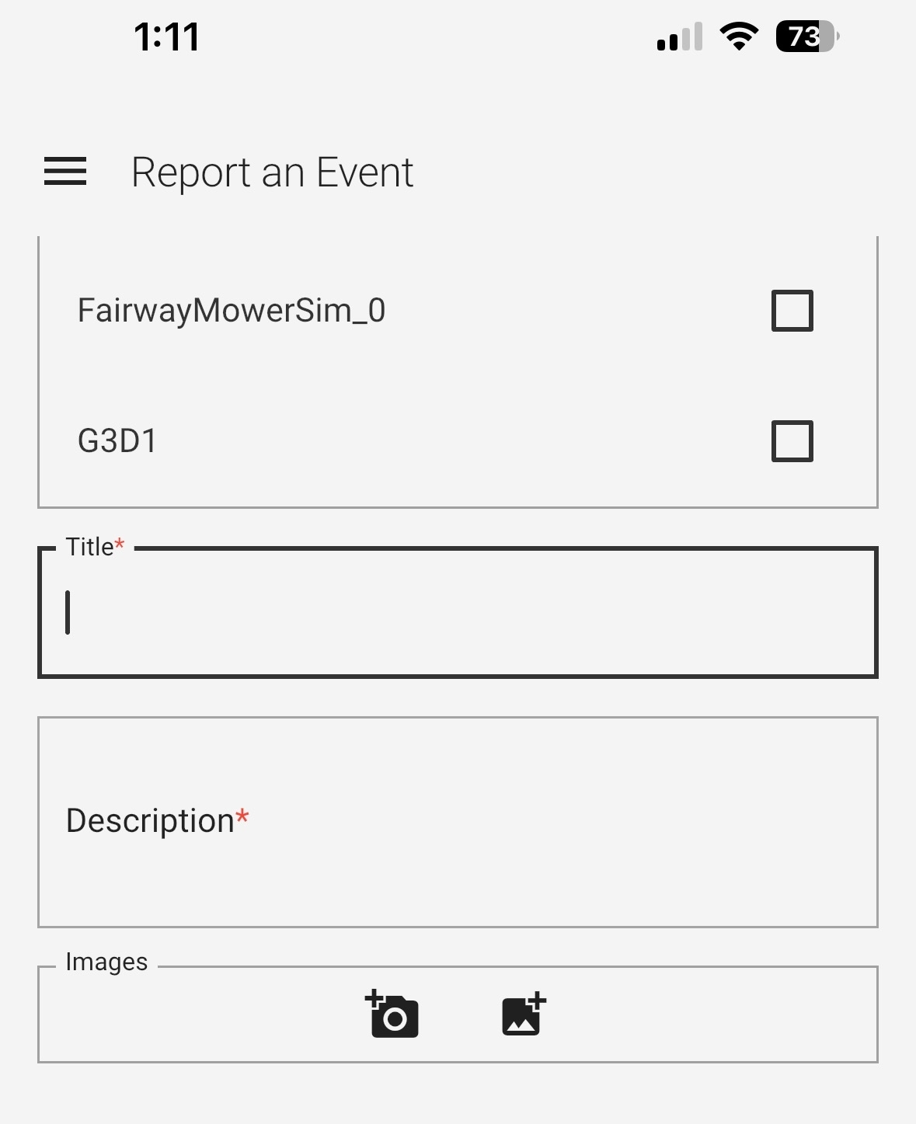
Tap the icon to take a new photo | Permission to use the camera will be requested if this is the first time this feature has been used on this device. Once permission has been granted the Phone camera will open
Take a photo and press the Use Photo | The Report and Event screen will open and the image will be listed in the images section above the icons to add more images
Tap the icon to add a photo from the photo gallery | The photo gallery will open for the device
Select an image or images to be added | The images will be added to the Images section of the event report page. If there are more images than can fit in the Images section the user will be able to scroll through all the listed images
Press the X on one of the images listed | That image will be removed from the list
Fill out the remainder of the event report steps and press report | Event report will be reported to the server and should contain the images in the report in the server
Upstream Relationships:
LFWM2-CMPRQ-3 Gallery Photos on Error Reports
LFWM2-CMPRQ-2 Mobile Photos on Error Reports
LFWM2-VERTC-979 | Event Report Default Log Times
Objective:
- To validate the default time selection when a user creates an Event Report.

Scope:
- Event Report creation.

Assumptions:
- Mobius Server is running in an environment where both Mobius Desktop client and Mobile App can be used.

Verification Method
Steps
Action | Expected Results | Notes
Using an iPhone  While Mobius Mobile app is running, navigate to the Event Creation section of Mobius.Create an Event report | The default time selection will be from the time the Event Report was created and back in time 10 minutes.
Using an Android  While Mobius Mobile app is running, navigate to the Event Creation section of Mobius.Create an Event report | The default time selection will be from the time the Event Report was created and back in time 10 minutes.
Using Mobius Desktop client  While Mobius Mobile app is running, navigate to the Event Creation section of Mobius.Create an Event report | The default time selection will be from the time the Event Report was created and back in time 10 minutes.
Upstream Relationships:
LFWM2-SubSys_Rqmt-47 Event Report Default Log Times
LFWM2-VERTC-980 | Verify VCU Relay's Fault Codes
Objective:
- Verify that the VCU will Relay Fault codes delivered by the SMU

Scope:
- Tests SMU error reporting by the VCU to the Mobius Server

Assumptions:
- Latest "testable" SMU software version loaded
- Latest "testable" VCU software version loaded

Verification Method
Steps
Action | Expected Results | Notes
Trigger a SMU Error on the Mower that is checked in and assigned to user | Error will be reported to Mobius and a notification will appear on both the client and the application
Upstream Relationships:
LFWM2-SubSys_Rqmt-64 VCU Relay Data
LFWM2-VERTC-1198 | VAI filters bunker edges
Objective:
- Validation that the VAI filters the edges of bunkers without creating additional safety related issues

Scope:
- VAI
- LiDAR

Assumptions:
- Mobius is running
- A mower has been updated with a VAI that includes bunker edge filtering
- A map is published on the Mobius server
- A fairway shape has real bunkers next to the fairway
- A plan has been created for that fairway
- The mower is checked in to Mobius and operating normally

Verification Method
Steps
Action | Expected Results | Notes
While the mower is on a fairway with a plan that drives the mower near a bunker, start the mower on the plan. | The mower will start along the plan.
When the mower encounters a bunker edge, the mower may slow down to the VAI determined slowing zone speed (0.89m/s or 2mph).  The slowing zone is 2 meters out from the edges of the occlusion zone in all directions. | While the mower passes the bunker edge, the mower will not encounter a Hazard Zone Violation, and will not stop.
Perform steps 1 and 2 again on fairways with a bunker with angles 10-4, 2-8, and 12-6 | While the mower passes the bunker edge for each plan, the mower will not encounter a Hazard Zone Violation, and will not stop.
Upstream Relationships:
LFWM2-VERTC-1199 | Audible alarm will sound when obstacle is detected in Warning Zone
Objective:
- To validate the autonomous mower will sound an alarm when an obstacle is detected in the Warning Zone

Scope:
- VAI
- VCU
- LiDAR

Assumptions:
- Mobius is running
- A map is published on the Mobius server
- The map includes a drivable area fit to test in
- The mower is checked in to Mobius and operating normally
- The tester has access to an obstacle that does not pose a safety hazard

Verification Method
Steps
Action | Expected Results | Notes
While the mower is in Autonomous Mode, assign the mower to execute a plan that intersects the obstacle placed in the Preconditions. | The mower shall execute the plan assigned to it.
While the mower is executing the plan, the obstacle will be within 5 meters of the mower. | When the obstacle is within 5 meters of the mower in any direction, the VAI will communicate with the VCU, and the VCU will send a command to the sounders on the mower to start their Warning Zone pattern alarm.
Perform steps 1 and 2, but with the mower moving in reverse towards the obstacle.  In order to create a PTP/waypoint plan that forces the mower to drive in reverse, hold the Shift button on your keyboard and left click with the mouse behind the mower. | When the obstacle is within 5 meters of the mower in any direction, the VAI will communicate with the VCU, and the VCU will send a command to the sounders on the mower to start their Warning Zone pattern alarm.
Perform steps 1 and 2, but with the mower driving past the obstacle.  Simply move the obstacle to one side or the other from the mower's desired path of travel. | When the obstacle is within 5 meters of the mower in any direction, the VAI will communicate with the VCU, and the VCU will send a command to the sounders on the mower to start their Warning Zone pattern alarm.
Upstream Relationships:
LFWM2-VERTC-1200 | Audible alarm will sound when obstacle is detected in Hazard Zone
Objective:
- To validate the autonomous mower will sound an alarm when an obstacle is detected in the Hazard Zone

Scope:
- VAI
- VCU
- LiDAR

Assumptions:
- Mobius is running
- A map is published on the Mobius server
- The map includes a drivable area fit to test in
- The mower is checked in to Mobius and operating normally
- The tester has access to an obstacle that does not pose a safety hazard

Verification Method
Steps
Action | Expected Results | Notes
While the mower is in Autonomous Mode, assign the mower to execute a plan that intersects the obstacle placed in the Preconditions. | The mower shall execute the plan assigned to it.
While the mower is executing the plan, the obstacle will be within 1.1 meters of the mower. | When the obstacle is within 1.1 meters of the mower in any direction, the VAI will communicate with the VCU, and the VCU will send a command to the sounders on the mower to start their Warning Zone pattern alarm. The VAI will also raise a flag that there is an obstacle in the Hazard Zone. The VAI will send that flag to the VCU, the VCU will send an error to the user stating there is a Hazard Zone Violation.  The VCU will also kill the engine on the mower, but will keep the alarms active.
Perform steps 1 and 2, but with the mower moving in reverse towards the obstacle.  In order to create a PTP/waypoint plan that forces the mower to drive in reverse, hold the Shift button on your keyboard and left click with the mouse behind the mower. | When the obstacle is within 1.1 meters of the mower in any direction, the VAI will communicate with the VCU, and the VCU will send a command to the sounders on the mower to start their Warning Zone pattern alarm. The VAI will also raise a flag that there is an obstacle in the Hazard Zone. The VAI will send that flag to the VCU, the VCU will send an error to the user stating there is a Hazard Zone Violation.  The VCU will also kill the engine on the mower, but will keep the alarms active.
Perform steps 1 and 2, but with the mower driving very close (within 1.1 meters) past the obstacle.  Simply move the obstacle to one side or the other from the mower's desired path of travel. | When the obstacle is within 1.1 meters of the mower in any direction, the VAI will communicate with the VCU, and the VCU will send a command to the sounders on the mower to start their Warning Zone pattern alarm. The VAI will also raise a flag that there is an obstacle in the Hazard Zone. The VAI will send that flag to the VCU, the VCU will send an error to the user stating there is a Hazard Zone Violation.  The VCU will also kill the engine on the mower, but will keep the alarms active.
Upstream Relationships:
LFWM2-VERTC-1207 | Jira ticket creation automation more than once a day
Objective:
- Validate that Mobius Server will automatically populate the Customer Support Landscaping Jira space with Error Reports created on each instance of Mobius Server multiple times per day, per configuration settings.

Scope:
- Mobius Server

Assumptions:
- Error report creation is functional.
- Error reports are being created throughout the day.
- Jira Customer Support Landscaping space (CSL) is accessible.
- The default time set to automatically send error reports to Jira is set to 1:00pm and 12:00am local time.

Additional Information
This is the location of the .json file to edit the times error reports are pulled into Jira: C:\ASI\MobiusServer\ticketgenerator.appsettings.json

Verification Method
Steps
Action | Expected Results | Notes
Step 1 needs to take place before 1:00pm local time.  With Mobius Server running, and logged in as any user, navigate to the Error Report creation window. Create an error report. | An error report will be created and saved on the server. | Error report creation screen can be found under the username in the top right corner of Mobius. Can be accessed at any point when running Mobius. Error report name does not matter.
Wait for 1:00pm to pass. After 1:00pm has passed, navigate to the CSL Jira space. | In the CSL Jira space, the test ticket created on the server will be present.
While Mobius Server is running, and the error report created before 1:00pm has been automatically sent to Jira, navigate to the Error Report creation window. Create another error report. | An error report will be created and saved on the server.
Wait for 12:00am to pass. After 12:00am has passed, navigate to the CSL Jira space. | In the CSL Jira space, the test ticket created on the server will be present.
Upstream Relationships:
LFWM2-SubSys_Rqmt-158 Error Report Jira Ticket Automation
LFWM2-VERTC-1217 | Verify mobius shall stop vehicle if off path error maximum is exceeded
Objective:
- Verify that if the vehicle exceeds the defined off path error mobius shall stop the vehicle.

Scope:
- Mobius Client and Server
- VCU

Assumptions:
- <Note any assumptions made prior to testing.>

Verification Method
Steps
Action | Expected Results | Notes
Navigate to Settings > Vehicles (User assigned vehicle) > VCU configuration > Maximum Allowed Off Path Error | Maximum Allowed Off Path Error configuration is shown
Set Maximum Allowed Off Path Error to 0.1 | Maximum Allowed Off Path Error adjusted to 0.1
In command mode, generate a waypoint and start vehicle on path with a sharp turn | Vehicle will stop when Maximum Allowed Off Path Error is exceeded
Revert Maximum Allowed Off Path Error to original value | Maximum Allowed Off Path Error adjusted to original value
Start vehicle along path again | Vehicle should complete path unless Maximum Allowed Off Path Error is exceeded again
Upstream Relationships:

